Reference:
Panda, S. and Das, N. C. (2002). Seasonal fluctuation in arsenic
content in groundwater and pond water.
In: Basu, S. (Ed.) (2002). Changing Environmental Scenario of the Indian Subcontinent. acb publications, Kolkata. ISBN 81-87500-09-3 (HB), ISBN 81-87500-08-5 (PB). pp. 415 – 420.

CHANGING
ENVIRONMENTAL SCENARIO
of The Indian Subcontinent

Editor
Subhashranjan Basu
Department of Geography
University of Calcutta

acb publications
2002

Seasonal Fluctuation in Arsenic Content in Groundwater and Pond Water

S. Panda
N. C. Das

From an inventory survey (1998-2000) on land and water use pattern of Gotera mauza in the Chakdaha Block of the Nadia district of West Bengal it was revealed that ponds were contaminated with arsenic by people's prac-
tice of filling the ponds with tubewells in non-rainy periods of the year mainly during pre-monsoon (April-May) and even in monsoon (June-September) periods. The analytical results during 1999-2000 showed that there was temporal variation in arsenic content both in groundwater and pond water. Suspended solids in pond water contributed to the total arsenic content of unfiltered pond water. Storing of groundwater in ponds would be helpful for lowering of arsenic content and sedimentation of suspended solids in ponds would further lower the arsenic contamination. The process of dearsenification of arsenic contaminated groundwater stored in ponds would be a very effective method regarding peoples' practice.

Introduction
An inventory survey (1998-2000) was conducted on land and water use pattern of the Gotera mauza under new alluvial zone of the Gangetic delta in West Bengal (Das and Panda, 2000). The survey revealed that ponds were continuously mixed with arsenic contaminated groundwater through practice of filling the ponds with tubewell water in non-rainy periods mainly during pre-monsoon (April-May) and even in monsoon (June-September) periods simply due to keeping in storage some water in ponds to supply irrigation water for both boro (summer) and kharif (winter) rice crops if shallow tubewells (STW) and deep tubewell (DTW) fail. Results of analysis of water
for arsenic content in groundwater and pond water of Gotera mauza are presented in this paper

Materials and Methods
Out of 43 shallow tubewells (STW) including six mini-deep tubewells in the Gotera mauza and nine (STW-8) of four adjacent mauzas viz. Mandalhat,
415

Changing Environmental Scenario of the Indian Subcontinent

Ramkrishnapur, Paschimsatberia and Ghentugachhi which supply irrigation water in Gotera 13 (STW) were selected as sample tubewells covering Gotera; and two dug wells (DW) one each in Ghentugachhi and one in Gotera were taken as samples; and one observation well (OW) in the ordinary hydro-me-
teorological station of the Arsenic project of BCKV at Ghentugachhi was also selected as sample tubewell. These sample tubewells were monitored for groundwater level (mbgl: meters below ground level) and collection of ground-
water samples for analysis of arsenic content. The range of depth of these STWs and OW were 27.43m to 60.96m and depths of two DWs were 9.75m and 5.49m. Out of total 91 ponds (10.588 ha) in Gotera 15 ponds (4.31 ha) were selected as sample ponds based on the size of different ponds. The range of depth (bank to bottom) of these ponds was 1.63 m to 3.27 m. Those sample ponds were monitored throughout the year during 1999 and 2000 for depth of water (for estimation of water available in ponds in Gotera) and collection of pond water for analysis of arsenic content. The pond water was filtered through Whatman filter paper No.42 for separating filtered pond water in the flask and suspended solids of pond water on the filter paper on funnel. For estimation of arsenic content in suspended solids filter paper with suspended solids was digested in triacid mixture (Jackson, 1973). The acid digested filtered solution was then taken for arsenic analysis.

Table 1 Seasonal groundwater level (m bgl) in Gotera mouza (Block Chakdaha, District - Nadia, West Bengal) as monitored from fourteen shallow tubewells (STW) and two dug wells (DW) during 1999 and 2000.
Groundwater level (m bgl)
STW/DW. Pre-monsoon Monsoon Post-monsoon
Sl. No. (April-May) (June-September) (October-November)
1999 2000 1999 2000 1999

STW I 4.085 CM CM CM CM
2 3.855 CM CM CM CM
3 6.230 4.65 4.620 3.450 0.320
4 6.000 CM CM CM CM
5 6.670 CM 4.100 CM CM
6 4.840 4.200 3.510 CM CM
7 5.280 4.900 4.110 0.120 0.570
8 4.770 3.400 3.510 0.120 0.210
9 5.135 4.600 3.760 0.210 0.250
10 4.880 5.200 3.840 0.110 0.810
1 1 3.660 4.200 2.690 0.060 0.610
12 4.000 3.100 2.820 CM CM
13 - 5.200 3.700 CM CM
14 - 4.750 - 3.450 1.450
DW 15 - 1.950 1.425 1.320 1.920
" 16 - 1.100 0.480 0.140 1 .270
CM = Could not be monitored.

416

Seasonal Fluctuation in Arsenic Content

Arsenic contents (mg.l⁻¹') of groundwater, filtered pond water and acid digested solution of suspended solids of pond water were separately analysed through atomic absorption spectrophotometer coupled with hydride genera-
tor after reduction of the water and extracted solution with KI and concentrated HCI. Analysed data were presented with respect to four different seasons in a year viz. dry (December-March), pre-monsoon (April-May), monsoon (June-September), and post-monsoon (October-November).

Results and Discussion
Seasonal groundwater levels (Table I) are the lowest in post-monsoon and the highest in pre-monsoon periods in the year whereas the arsenic content of groundwater (Table 2) follows the same pattern. With the onset of monsoon season arsenic content increases and in the mid monsoon period (i.e. late July-early August) it is higher, then arsenic content decreases and the least arsenic content is estimated during post monsoon period (Figure 1).
Seasonal variation in estimated volume of water in ponds showed the least volume in dry and pre-monsoon seasons and the highest during post-mon-
soon season (Table 3), whereas no specific pattern was found in case of total arsenic content of pond water throughout the year (Table 4 and Figure 1).

Table 2 Seasonal arsenic status of groundwater level (mg.!') in Gotera mauza (Block Chakdaha, District - Nadia, West Bengal) as monitored from fourteen
shallow tubewells (STW) and two dug wells (DW) during 1999 and 2000.

Groundwater level (m bgl)
STW/D W. Pre-monsoon Monsoon Post-monsoon
SI. No. (April-May) (June-September) (October-November)
1 999 2000 1999 2000 1999
STW 1 0.200 - - - -
2 0.113 - - - -
3 0.014 0.188 0.070 0.100 0.061
4 0.110 - - - -
5 0.012 - 0.038 - -
6 0.081 0.1 1 2 0.031 - -
7 0.033 0.126 0.105 0.157 0.002
8 0.335 0.1 81 0.113 0.193 0.014
9 - 0.127 0.073 0.148 0.022
10 0.008 0.148 0.058 0.056 0.025
I 1 0.001 0.143 0.053 0.047 0.054
12 0.093 0.150 0.179 - -
13 - 0.132 0.874 - -
14 - 0.135 - 0.138 0.057
DW 15 - 0.058 0.044 0.024 0.060
16 - 0.048 0.042 0.037 0.046

417

Changing Environmental Scenario of the Indian Subcontinent

Table 3 Estimated volume of water (ha-m) in existing ponds in Gotera mauza (Block Chakdaha, District - Nadia, West Bengal) as estimated from fifteen sample ponds comprising an area of about 4.931 ha out of total 10.588 ha pond area in the mauza during 1999 and 2000.
Estimated volume of water (ha-m) in existing ponds in Gotera mauza
Seasons
Dry Pre-monsoon Monsoon Post-monsoon
Years (December-March) (April-May) (June-September) (October-November)
1990 - 8.541 14.528 15.605
2000 9.582 9.624 17.269 -

During post-monsoon to dry period arsenic content of pond water is somewhat less in a year when (i.e. early October to late part of March) the possibility of using pond water for irrigation is the least due to no demand for irrigation for paddy. So, the least arsenic content of pond water during post monsoon to dry period in a year would be due to natural dearsenification of contaminated groundwater in the ponds.
Suspended solids always contribute to the total arsenic content of pond wa-
ter and that contribution is always the highest during pre-monsoon to monsoon (early April to late September) (Table 4 and Fig.2). Those suspended solids after flocculation would be sedimented at the bottom of the ponds and, thus, through such sedimentation process the pondwater would be further dearsenified.

Table 4 Seasonal variations in arsenic content ( mg.l⁻¹) of pond water l filtered
water ( FW ) + suspended solid ( SS) I + w.r.t. fifteen sample ponds in Gotera mauza (Block Chakdaha, District - Nadia, West Bengal)

Arsenic content (mg.l⁻¹) of pond water
Season
Drv Pre-monsoon Monsoon Post-monsoon
FW SS Total FW SS Total FW SS Total FW SS Total

1999 0.01 0.009 <0.001 0.012 0.011 <0.001 0.010
to to to to to to to
0.382 0.096 0.028 0.124 0.045 0.012 0.045
2000
0.0003 0.031 0.027 0.011 0.005 0.021 0.010 0.001 0.020
to to to to to to to to to
0.01 0.108 0.0115 0.099 0.043 0.127 0.097 0.520 0.590

+ Arsenic content of pond water = arsenic content of filtered water (FW) + suspended solid (SS) (filtered through Whatman Filter paper No. 42).

418

Seasonal Fluctuation in Arsenic Content
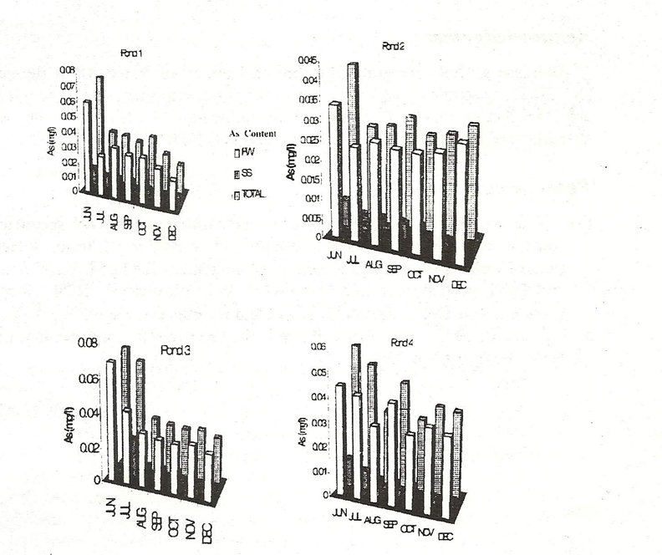
Figure 1 Monthly arsenic content of pond water in Gotera mouza
in 1999 (Total arsenic content = arsenic content of filtered water
(FW) and suspended solids (SS) ]

Conclusions
1. There would be natural dearsenification through stroring of contaminated groundwater in surface water bodies like pond.
2. Sedimentation of suspended solids in the surface water bodies (like pond) would further help the dearsenifying the contaminated groundwater stored in ponds.
3. Filtration of suspended solids from pond water would further reduce the arsenic contamination from the pond water.
4. These findings need location specific studies with regard to arsenic content of groundwater, mechanical separates (i.e. clay, silt, sand fractions) and organic matter content of sediments of the pond and associated percolation and evaporation losses from the pond for specific technical back-up for a particular area.
5. If such process of dearsen i fi cation of contaminated groundwater gets approval, it would be highly beneficial for people as this process would be a low cost as well as a very much useful method for people.
419

Changing Environmental Scenario of the Indian Subcontinent

Acknowledgement
Both the authors are grateful to Indian Council of Agricultural Research (ICAR) for extending financial support for conducting research through Arsenic Project at BCKV. Grateful acknowledgement is also due to Dr. S.K. Sanyal, Principal Investigator, Arsenic Project, BCKV.

References
Das, N.C. and Panda, S. 2000. Water in agriculture - a critical scenario in
some arsenic affected areas of Nadia district. West Bengal, India. Interna-
tional Conference on Land Resource Management for Food, Employment
and Environmental Security (ICLRM), 9-13 November, 2000, Vigyan
Bhavan, New Delhi. Abstracts (contributory papers), page 50.
Jackson. M.L. 1973. Soil Chemical Analysis, Prentice Hall of India Pvt. Ltd.,
New Delhi, pp.326-339.

420
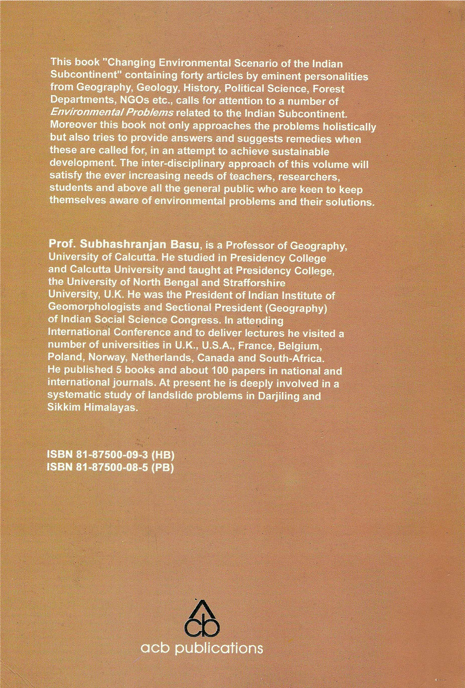
Published by Ajoy Bhattacharya of acb publications, P757 Block-A, Lake Town. Kolkata 700 089

